Unveiling market insight: analysis spending behaviour and identifying opportunities for growth

# 1.introduction

In an era defined by rapidly evolving consumer preferences and an ever-expanding array of market offerings, understanding and deciphering spending behaviors has become an indispensable facet for businesses aiming to thrive in competitive landscapes. This comprehensive analysis delves into the intricate dynamics of consumer spending patterns, unpacking crucial insights that serve as the bedrock for identifying untapped opportunities for sustainable growth. By scrutinizing a myriad of quantitative and qualitative data, this study seeks to provide a comprehensive overview of the factors driving consumer spending, thereby facilitating a nuanced understanding of market trends and potential growth avenues. Through this exploration, we aim to equip businesses with the necessary tools to optimize their strategies, enhance customer engagement, and carve out a distinctive market position that aligns with the ever-evolving demands of the contemporary consumer landscape.

# 1.1.overview:

1.**Consumer Spending Analysis:** This analysis delves into the intricate details of consumer spending habits, investigating what, when, and why consumers make purchasing decisions. By dissecting these patterns, we aim to shed light on the motivations and triggers behind consumer choices.

2. **Market Trends and Dynamics:** The study explores the ever-changing landscape of market trends, considering the impact of external factors such as economic conditions, technological advances, and cultural shifts. This broader perspective enables businesses to anticipate market movements.

3. **Segmentation and Targeting:** Understanding that one size does not fit all, this analysis breaks down consumer groups by demographics, preferences, and behaviors, facilitating more effective marketing and product development strategies.

4. **Opportunity Identification:** Through an exhaustive examination of data, we identify untapped opportunities for businesses to enhance their products, services, and marketing efforts. By recognizing gapsin the market, companies can position themselves as industry leaders.

5. **Competitive Insights:** We also consider the strategies of key industry players, unveiling their approaches to meet evolving consumer demands. This insight enables businesses to stay competitive and differentiate themselves effectively.

6. **Future-Proofing Strategies:** In an era of continuous change, we offer forward-looking strategies to future-proof businesses by adapting to shifting consumer behavior, technology advancements, and regulatory changes.

# 1.2 purpose

1. **Understanding Consumer Behavior:** The study endeavors to decode the underlying factors that influence consumer spending decisions, providing businesses with a nuanced understanding of the motivations, preferences, and purchasing triggers of their target audience.

2. **Identifying Growth Opportunities:** By meticulously examining market trends and consumer spending patterns, the analysis aims to uncover untapped opportunities for businesses to expand their market share, innovate products and services, and devise effective marketing strategies that resonate with evolving consumer needs.

3. **Enhancing Competitive Advantage:** Through a comprehensive evaluation of industry dynamics and competitor strategies, the study enables businesses to refine their competitive positioning, identify gaps in the market, and leverage their strengths to stay ahead in an increasingly competitive business landscape.

4. **Optimizing Resource Allocation:** By providing insights into consumer preferences and market trends, the study assists businesses in optimizing their resource allocation, directing investments toward high-potential areas and minimizing wastage on strategies that may not align with current market demands.

5. **Driving Sustainable Growth:** With a focus on long-term sustainability, the analysis aims to equip businesses with the knowledge and tools necessary to build resilient and adaptable strategies that can withstand market fluctuations and changing consumer preferences, fostering enduring growth in the face of dynamic market challenges.

# 2.Problem statement & design thinking:

# 2.1empathy map

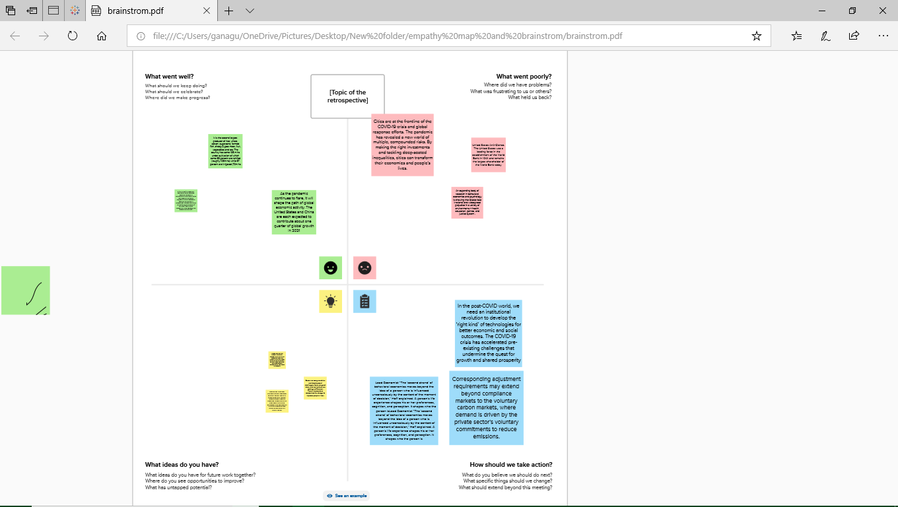

2.2.identation and brainstorming map:

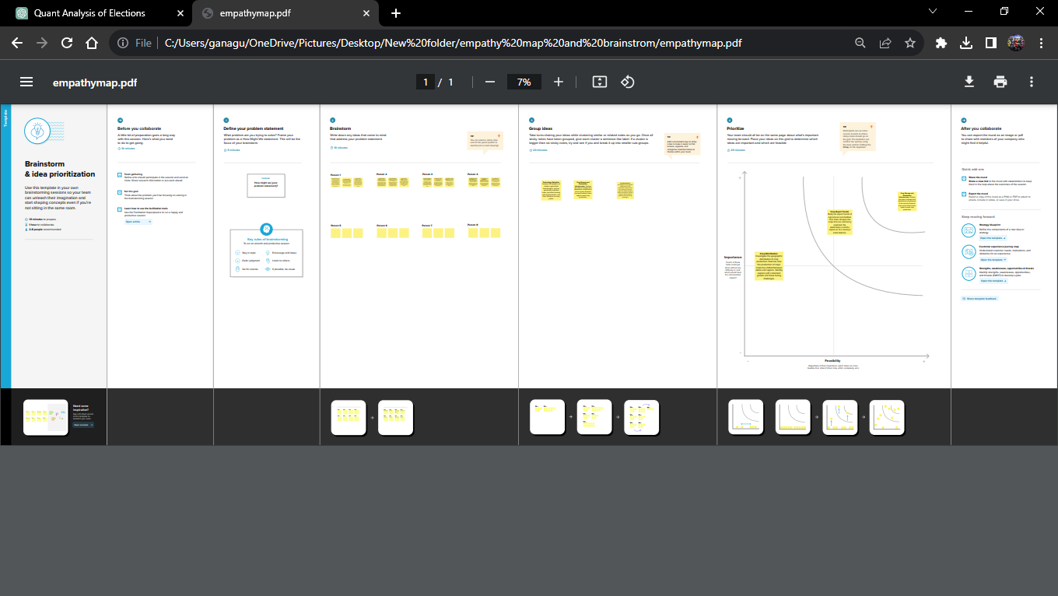

# 3.results:

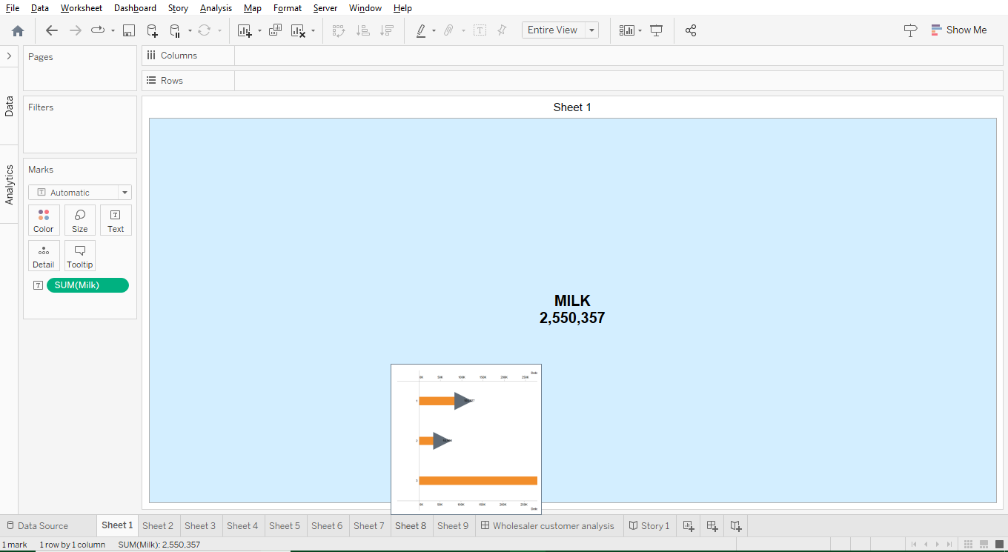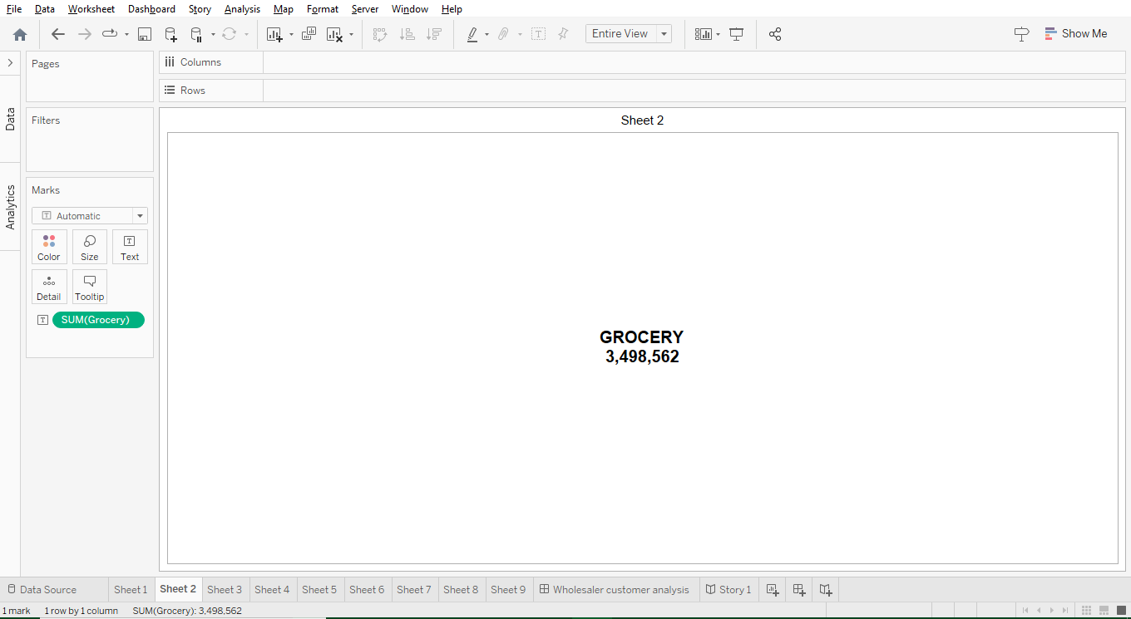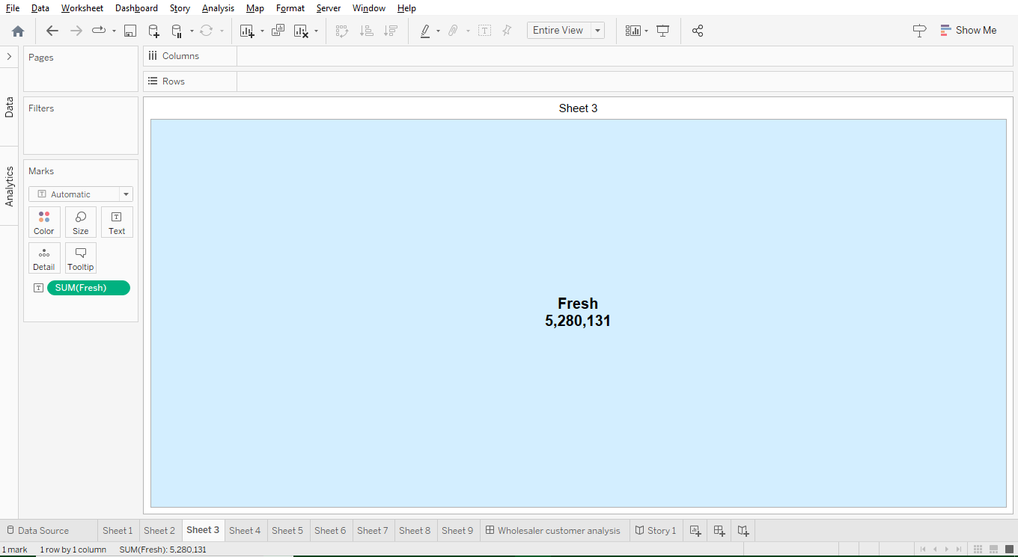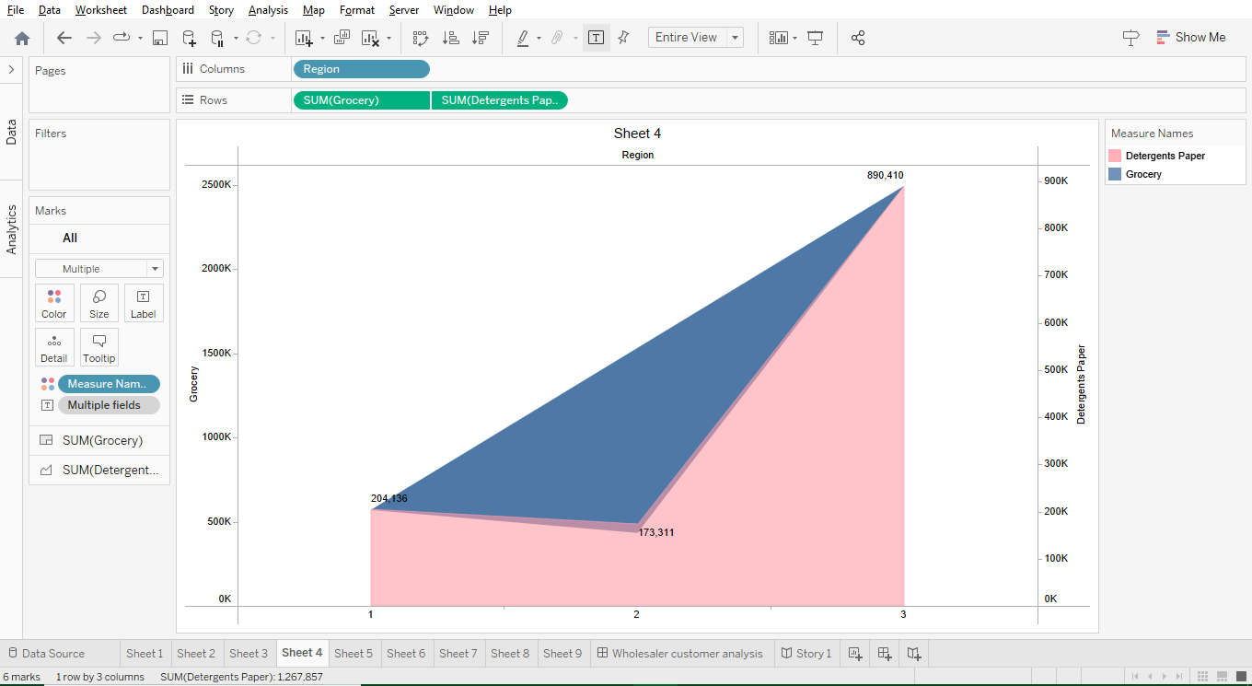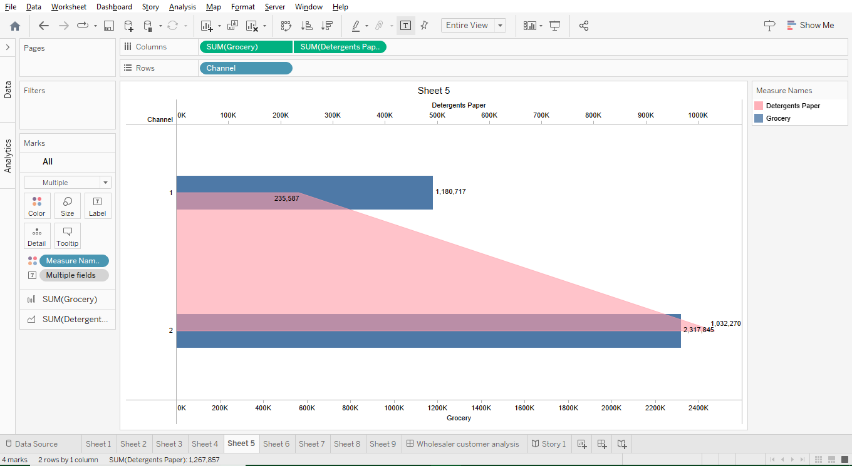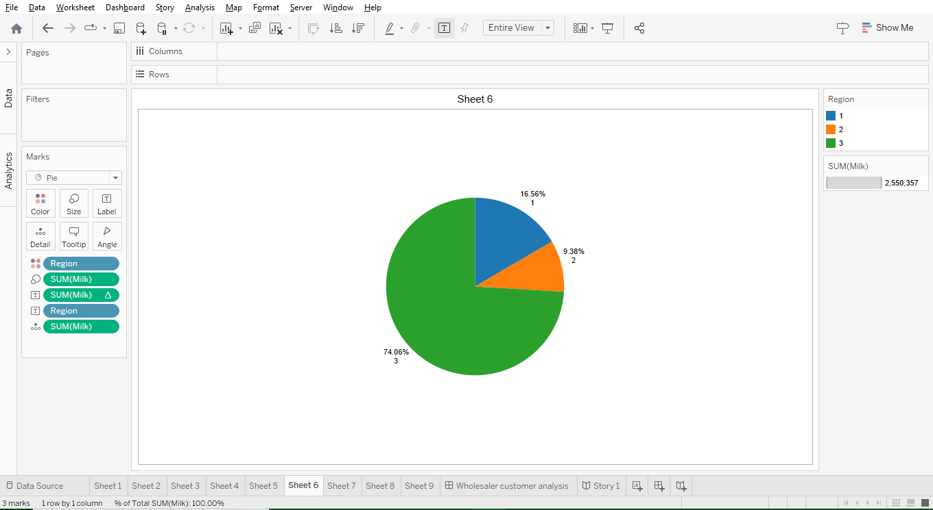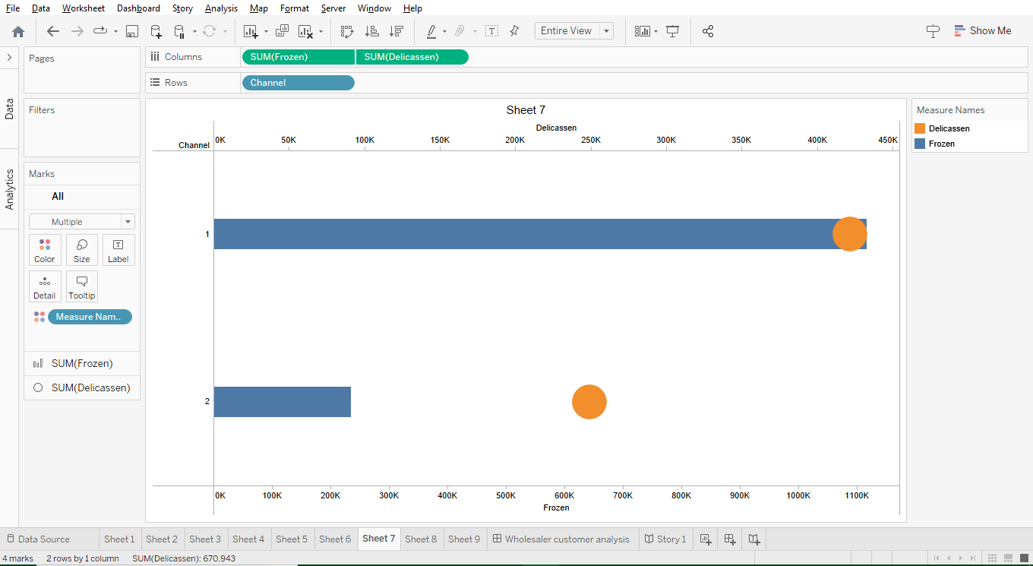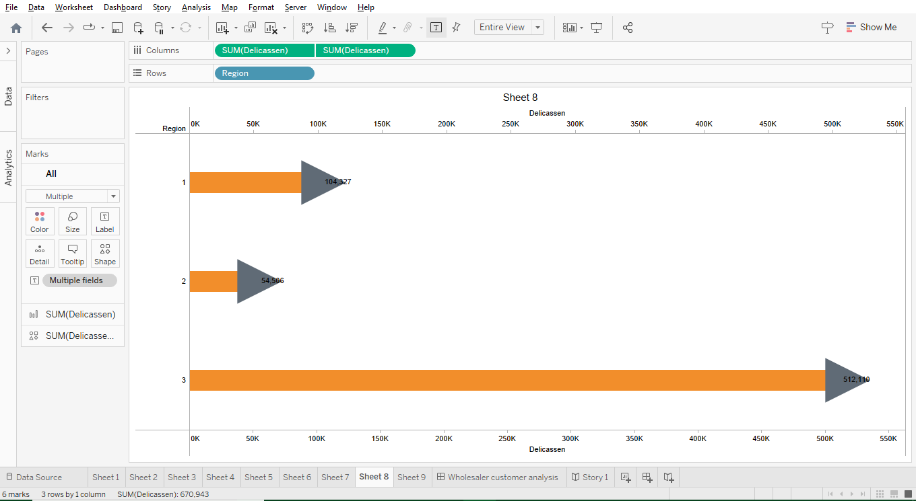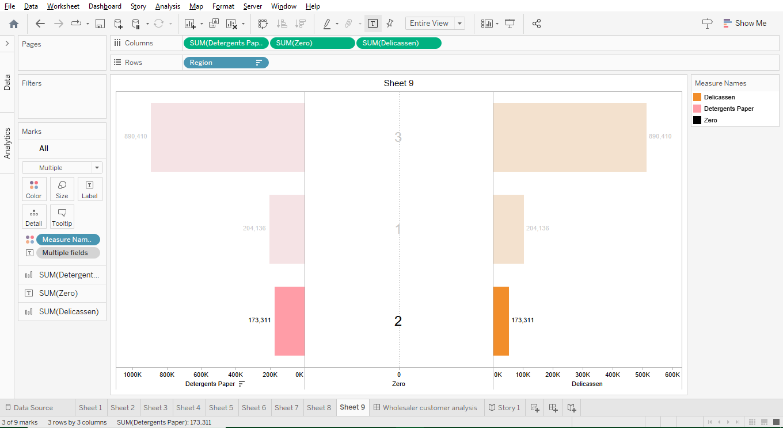

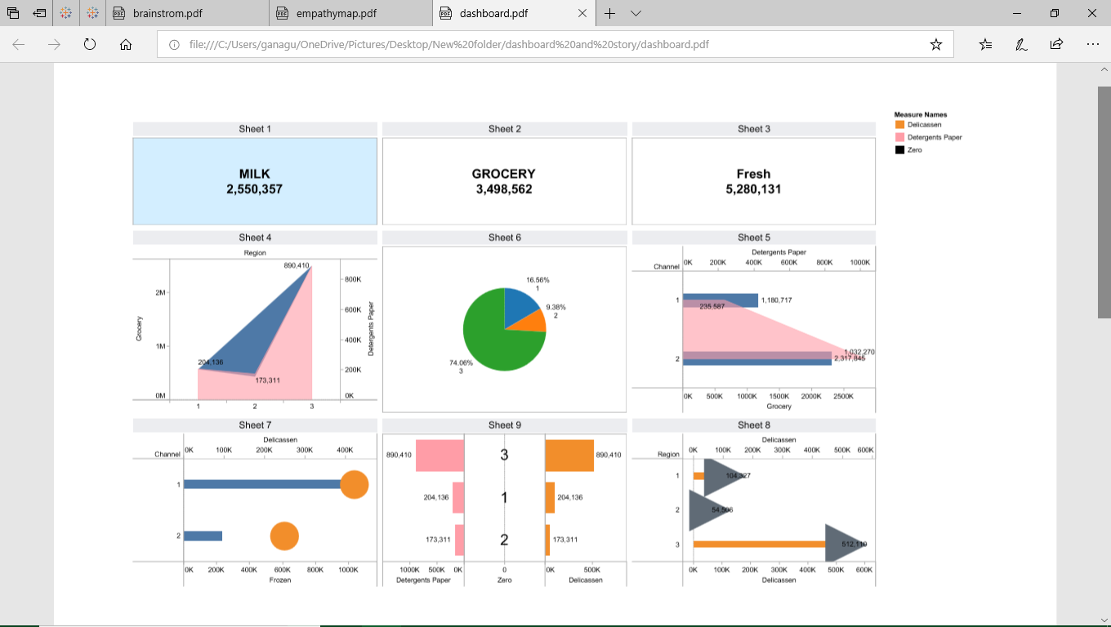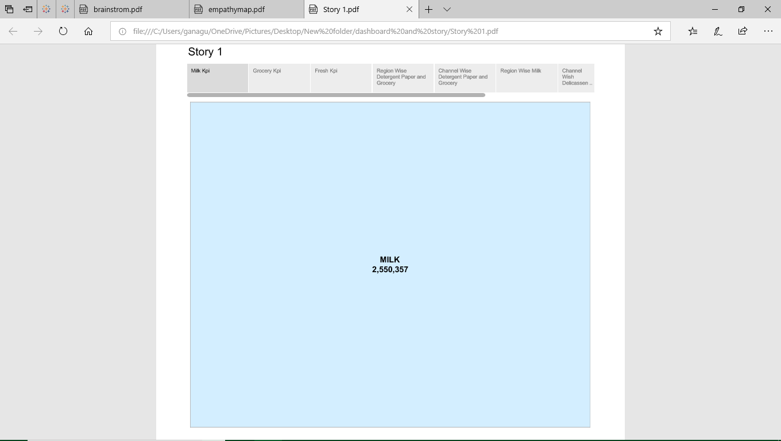

# 4.Advantages & disadvantages:

**Advantages:**

**1.Informed Decision-Making:** The insights garnered from the study can significantly improve the quality of decision-making within businesses, enabling them to make more informed choices regarding product development, marketing strategies, and resource allocation.

**2.Competitive Edge:** Understanding consumer behavior and identifying growth opportunities can provide a significant competitive advantage, allowing businesses to stay ahead of their competitors and capture a larger market share.

**3.Enhanced Customer Engagement:** By gaining insights into consumer preferences, businesses can tailor their offerings and marketing campaigns to better resonate with their target audience, leading to increased customer satisfaction and loyalty.

4.**Maximized ROI:** Through a comprehensive understanding of market trends and consumer behavior, businesses can allocate their resources more effectively, ensuring that investments are directed towards high-potential areas, thereby maximizing return on investment (ROI).

**5.Long-Term Sustainability:** By identifying and capitalizing on growth opportunities, businesses can develop sustainable strategies that are adaptable to changing market dynamics, ensuring long-term success and resilience in the face of market fluctuations.

**Disadvantages:**

**1.Data Complexity:** Conducting an in-depth analysis of market insights can be a complex and resource-intensive process, requiring a significant investment of time, money, and expertise to ensure the accuracy and reliability of the findings.

**2.Data Interpretation Challenges:** Interpreting complex market data and consumer behavior patterns may pose challenges, and misinterpretation of data could lead to faulty conclusions, potentially resulting in ineffective business strategies.

**3.Market Uncertainties:** Despite thorough analysis, the market is inherently unpredictable, and consumer behavior can change rapidly due to various external factors, making it challenging to predict market trends with complete accuracy.

**4.Cost Considerations:** Undertaking a comprehensive market analysis may involve substantial costs, including the acquisition of data, hiring expert analysts, and implementing recommended strategies, which could strain the financial resources of some businesses.

**5.Competitive Risks:** While understanding market insights can provide a competitive edge, there is a risk that competitors may also gain access to similar insights, leading to intensified competition and the need for continual innovation to maintain market leadership.

# 5.Application:

1. **Product Development and Innovation:** Utilize the insights to tailor products and services to better meet the specific needs and preferences of the target consumer demographic, leading to the development of more relevant and competitive offerings.
2. **Targeted Marketing Strategies:** Apply the insights to create more targeted and effective marketing campaigns, ensuring that promotional efforts are directed at the right audience, through the appropriate channels, and with messaging that resonates with their spending behaviors and preferences.
3. **Customer Relationship Management (CRM):** Implement the insights to enhance customer engagement and improve customer satisfaction by personalizing interactions, anticipating needs, and delivering tailored solutions that align with the identified spending behaviors and patterns.
4. **Resource Allocation Optimization:** Use the insights to optimize resource allocation, directing investments toward areas with the highest potential for growth and profitability, while minimizing unnecessary expenditure on strategies that may not align with current market trends and consumer preferences.
5. **Market Expansion and Diversification:** Leverage the insights to identify new market segments or untapped opportunities for growth, facilitating strategic expansion into new demographics, regions, or product categories that align with the identified consumer spending behaviors and preferences.
6. **Risk Management and Mitigation:** Apply the insights to anticipate potential market shifts and consumer behavior changes, allowing for proactive risk management and mitigation strategies to be implemented, thereby reducing the potential negative impacts of market uncertainties.
7. **Long-Term Business Strategy Development:** Utilize the insights to inform the development of long-term business strategies that are adaptable and resilient to changing market dynamics, ensuring sustained growth and relevance in an ever-evolving business environment.

# 6.Conclusion:

The comprehensive analysis conducted in this study, "Unveiling Market Insights - Analyzing Spending Behavior and Identifying Opportunities for Growth," has provided valuable and actionable insights into the intricate dynamics of consumer spending behavior, unlocking a wealth of opportunities for businesses to achieve sustainable growth and competitiveness.

Through a meticulous examination of market trends, consumer preferences, and industry dynamics, this study has illuminated the path for businesses to make informed decisions, optimize resource allocation, and tailor their strategies to meet the ever-evolving demands of the market. By understanding the motivations and triggers behind consumer spending, businesses can effectively refine their product offerings, marketing strategies, and customer engagement initiatives, leading to enhanced customer satisfaction and loyalty.

The identification of untapped growth opportunities, coupled with strategic recommendations for market expansion and diversification, has positioned businesses to capitalize on emerging trends and solidify their competitive edge in the industry. Furthermore, the insights provided in this analysis serve as a robust foundation for the development of sustainable long-term strategies that are adaptable to the changing market landscape, thereby ensuring continued success and resilience in the face of market uncertainties.

As businesses navigate the complexities of the modern business environment, the insights gleaned from this study will serve as a compass, guiding them toward strategic decisions that not only maximize profitability and growth but also foster lasting relationships with their customers. By leveraging the power of data-driven insights, businesses can continue to innovate, evolve, and thrive in an ever-changing marketplace, ensuring their relevance and success for years to come

# 7.Future scope:

1. **Predictive Analysis and Forecasting:** Utilize advanced data analytics and predictive modeling techniques to anticipate future consumer spending behavior and market trends, enabling businesses to proactively adjust their strategies and offerings to meet evolving consumer demands.
2. **Integration of Emerging Technologies:** Explore the integration of artificial intelligence, machine learning, and big data analytics to enhance the depth and accuracy of market insights, allowing businesses to gain a more comprehensive understanding of consumer behavior and preferences in real-time.
3. **Global Market Expansion:** Extend the analysis to explore global market dynamics and consumer behavior trends, enabling businesses to identify opportunities for international expansion and develop tailored strategies to cater to diverse consumer segments across different geographical regions.
4. **E-Commerce and Digital Market Analysis:** Focus on analyzing spending behavior and trends within the digital marketplace, considering the increasing prominence of e-commerce and online consumer interactions, to help businesses optimize their online presence and enhance their digital marketing strategies.
5. **Sustainable and Ethical Consumer Behavior:** Investigate consumer preferences for sustainable and ethically sourced products, enabling businesses to align their offerings with the growing demand for environmentally friendly and socially responsible goods and services, thus contributing to a more sustainable and responsible business ecosystem.
6. **Consumer Sentiment Analysis:** Dive deeper into understanding consumer sentiment and emotions surrounding their spending behavior, incorporating sentiment analysis techniques to gauge customer satisfaction, brand perception, and overall consumer experience, thereby allowing businesses to tailor their strategies to enhance customer engagement and loyalty.
7. **Cross-Industry Analysis:** Explore opportunities for cross-industry analysis, identifying parallels and trends across different sectors and industries, to enable businesses to leverage insights from diverse markets and apply successful strategies from one industry to another, fostering innovation and cross-pollination of ideas.